|  |
| --- |
|  |

|  |
| --- |
| Network Commands |
| Communications Systems |
|  |
|  |
|  |
|  |
|  |
|  |

* Ashley Bennett 000725945-X,
* Milena Krecisz 000724968-3
* Thomas Nairn 000744320,

Table of Contents

Task 1: 2

Task 2: Medium Access 2

Task 3: 3

Task 4: Pinging 3

Task 5: Trace route 5

Task 6: Netstat with appropriate parameters. 6

Appendix 7

# Task 1:

|  |  |  |  |  |  |  |  |  |  |  |
| --- | --- | --- | --- | --- | --- | --- | --- | --- | --- | --- |
|  | | Machine A | | | Machine B | | | | UNIX | |
| IPv4 Address | | 193.60.73.100 | | | 193.60.73.113 | | | | 193.60.76.235 | |
| Subnet Mask | | 255.255.255.0 | | | 255.255.255.0 | | | | 255.255.255.0 | |
| Default Gateway | | 193.60.73.1 | | | 193.60.73.1 | | | | - | |
| Machine's IP Class | | Class C | | | Class C | | | | Class C | |
| Machine's Netwo  rk Address | | 193.60.73.0 | | | 193.60.73.0 | | | | 193.60.76.0 | |
| Machine's Host Address | | 0.0.0.100 | | | 0.0.0.113 | | | | 0.0.0.235 | |
| Task 2: Medium Access **Control (MAC) Addresses** | |  | | | | |  | | | |
|  | | Machine A | | | | | Machine B | | | |
| Host Name | | KW116-069 | | | | | KW116-060 | | | |
| Physical Address | | 00-1C-C0-C2-AC-96 | | | | | 00-1C-C0-C2-AC-BF | | | |
| NIC Manufacturer | | Intel Corporate | | | | | Intel Corporate | | | |
| IPv4 Address | | 193.60.73.100 | | | | | 193.60.73.113 | | | |
| Subnet Mask | | 255.255.255.0 | | | | | 255.255.255.0 | | | |
| Lease Obtained | | 13 November 2012 10.58:09 | | | | | 13 November 2012 11:02:52 | | | |
| Lease Expires | | 20 December 2148 10.15:03 | | | | | 20 December 2148 18:01:54 | | | |
| Default Gateway Address | | 193.60.73.1 | | | | | 193.60.73.1 | | | |
| DHCP Server Address | | 193.60.48.8 | | | | | 193.60.48.8 | | | |
| DNS Servers Addresses | | 193.60.73.244 | | | | | 193.60.73.244 | | | |
| Primary WINS Server Address | | 193.60.52.230 | | | | | 193.60.52.230 | | | |
|  |  | | | | |  | | | | |
|  | Machine A | | | | | Machine B | | | | |
|  | Network Class | | Network Address | Host Address | | Network Class | | Network Address | | Host Address |
| IPv4 Address | C | | 193.60.73.0 | 0.0.0.100 | | C | | 193.60.73.0 | | 0.0.0.113 |
| Default Gateway Address | C | | 193.60.73.0 | 0.0.0.1 | | C | | 193.60.73.0 | | 0.0.0.1 |
| DHCP Server Address | C | | 193.60.48.0 | 0.0.0.8 | | C | | 193.60.48.0 | | 0.0.0.8 |
| DNS Servers Addresses | C | | 193.60.73.0 | 0.0.0.244 | | C | | 193.60.73.0 | | 0.0.0.244 |
| Primary WINS Server Address | C | | 193.60.52.0 | 0.0.0.230 | | C | | 193.60.52.0 | | 0.0.0.230 |

|  |  |  |
| --- | --- | --- |
| UNIX Command |  | Addresses |
| netstat -rn | Default Gateway Address | 193.60.73.1 |
| cat /etc/resolv.conf | DNS Servers Addresses | 193.60.49.84 |

Task 3: Computer 1 and Computer 2 are located on the same network and are able to communicate easily; Computer 3 will not be able to communicate as it is on a different network.   
1 or 2 wouldn’t communicate back to 3. But 3 can communicate to 1 ad 2.

|  |  |  |  |
| --- | --- | --- | --- |
|  | Computer 1 | Computer 2 | Computer 3 |
| IP Address | 192.168.12.113 | 192.168.12.205 | 192.168.112.97 |
| Subnet Mask | 255.255.255.0 | 255.255.255.0 | 255.255.255.0 |
| Default Gateway | 192.168.12.1 | 192.168.12.1 | 192.168.12.1 |

# Task 4: Pinging

|  |  |  |  |  |
| --- | --- | --- | --- | --- |
|  | 193.60.73.100/KW116-069 | 193.60.76.235/ Student | Ping from Windows Successful? | Ping from UNIX  Successful? |
| ping the IP address of a Windows computer | 193.60.73.113 | 193.60.73.113 | Yes | Yes |
| ping the IP address of a UNIX machine | 193.60.76.235 | 193.60.76.235 | Yes | Yes |
| ping the IP address of the default gateway | 193.60.73.1 | 193.60.76.1 | Yes | Yes |
| ping the IP addresses of  a DNS server | 193.60.73.244 | 193.60.49.84 | Yes | Yes |
| ping the Loopback IP address (If the ping is successful, then TCP/IP is properly installed and functioning on the computer.) | 127.0.0.1 | 127.0.0.1 | Yes | Yes |
| ping the hostname of another computer  (the UNIX hostname can be found with the hostname command) | student | KW116-069 | Yes | Yes |
| ping [www.cisco.com](http://www.cisco.com/) | 2.12.144.170 | 2.12.144.170 | Yes | Yes |
| ping [www.microsoft.com](http://www.microsoft.com/)  Notice that the DNS server was able to resolve the name to an IP address, but there is no response.  Some Microsoft routers are configured to ignore ping requests. This is a frequently implemented security measure | 65.55.57.27 | 65.55.57.27 | Request timed out. No answer | No answer from www.microsoft.com |

|  |  |
| --- | --- |
| Packet size | Average Time /seconds |
| 10 | 2.36 |
| 20 | 2.34 |
| 40 | 2.34 |
| 80 | 2.25 |
| 160 | 2.31 |
| 320 | 2.38 |
| 640 | 2.48 |
| 1280 | 2.75 |
| 2560 | 3.41 |
| 5120 | 4.18 |

The table and graph below show the results of our attempt to ping [www.cisco.com](http://www.cisco.com). The number of pings used was 5 and the packet size increased twice very time. The results form a trend in which we can see that as the packet size was getting larger the time taken for the ping to send was also gradually increasing.

The highest packet size we were able to send was 5120 as the doubled packet size which was 10240 was not able to display the transmission rate.

Task 5: Trace route

|  |  |  |  |  |  |  |
| --- | --- | --- | --- | --- | --- | --- |
| Environment | | Command | | | Average Delay | |
| Windows | | ping -n 5 -l 128 [www.cisco.com](http://www.cisco.com/) | | | 2ms | |
| UNIX | | ping -s [www.cisco.com](http://www.cisco.com/) 128 5 | | | 2.25ms | |
| Domain Name | IP addresses | Host Name | Network Address | Number of Hops -Windows | | Number of Hops - UNIX |
| [www.cms.gre.ac.uk](http://www.cms.gre.ac.uk/) | 193.60.77.235 | www.cms.gre.ac.uk | 193.60.77.0 | 2 | | 2 |
| staffweb.cms.gre.ac.uk | 193.60.76.168 | camus.cms.gre.ac.uk | 193.60.76.0 | 2 | | 2 |
| [www.gre.ac.uk](http://www.gre.ac.uk/) | 193.60.68.103 | ah-ils-web-squid1.gre.ac.uk | 193.60.68.103 | 4 | | 4 |

|  |  |  |  |  |  |
| --- | --- | --- | --- | --- | --- |
| Domain Name | IP addresses | Host Name | Network Address | Number of Hops -Windows | Number of Hops - UNIX |
| [www.google.co.uk](http://www.google.co.uk) | 173.194.66.94 | www.google.co.uk | 173.194.0.0 | 13 | 13 |
| [http://www.australia.com](http://www.australia.com/) | 92.122.126.218 | a1441.b.akamai.net | 92.0.0.0 | 8 | 8 |
| <http://www.dfo.gov.ru/> | 95.173.153.198 | www.dfo.gov.ru | 95.0.0.0 | 15 | 30 |

# Task 6: Netstat with appropriate parameters.

|  |  |  |  |  |
| --- | --- | --- | --- | --- |
| Task | Windows Command | UNIX Command | Windows | UNIX |
| Show all active connections | netstat | netstat -a | - | - |
| Show all active TCP connections in numerical form | netstat -ap tcp | netstat –aP tcp | - | - |
| Show all active TCP connections with Fully Qualified Domain Names for foreign addresses | Netstat -afp tcp | netstat -aP tcp -v | - | - |
| What are the number of IP packets received and sent since boot-up? How many were in error? | netstat -e | netstat -as | Received: 658873893 Sent: 51043012 Errors: 0 | Received : 1750538944  sent : 1711692247 Errors: 0 |
| What are the numbers of IP packets sent and received in a typical 10 second interval? | netstat –e t10 | netstat -s10 | Received : 611121  Sent:  102040 | Received 24114  Sent:  24024 |
| What are the numbers of TCP segments transmitted and received in a typical 20 second interval? How many retransmissions were there? | netstat -s 20 | netstat -s 20 | Segments Received: 339794  Segments Sent: 111803  Segments Retransmitted: 1869 | Received: 19905  Sent:  72948  Retransmitted:  120 |
| UDP datagrams - what are the numbers transmitted and received in a typical 20 second interval? | netstat -s 20 | netstat -s 20 | Datagrams Received = 64340  Datagrams Sent = 16953 | Received: 198  Sent :200 |
| How many ICMP messages were sent and received in a typical 20 second interval? | netstat -s 20 | netstat -s 20 | Received:1435 Sent:1135 | Received = 1  Sent =  1 |
| List the routing table entries | netstat -r | netstat -r | See appendix for routing table | See appendix for routing table |

# 

# Appendix

Windows routing table (netstat –r)

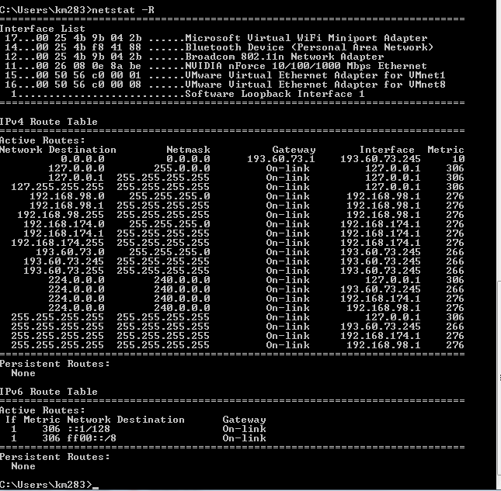

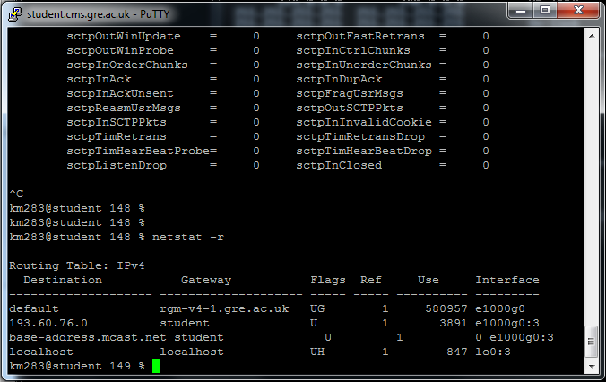UNIX routing table (netstat –r)